

Mark Scheme (Final)

Summer 2007

Edexcel Limited. Registered in England and Wales No. 4496750
Registered Office: One90 High Holborn, London WC1V 7BH


GCE



GCE Mathematics (6665/01)

June 2007

6665 Core Mathematics C3

Mark Scheme

Question Number | Scheme | Marks
1. (a) | 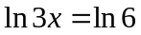 or ln x = ln 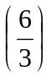 or ln 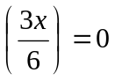 | M1
 | x = 2 (only this answer) | A1 (cso) (2)
(b) | 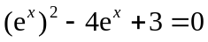 (any 3 term form) | M1
 | (e^{x} – 3)(e^{x} – 1) = 0
 | e^{x} = 3 or e^{x} = 1 Solving quadratic | M1 dep
 | x = 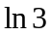, x = 0 (or ln 1) | M1 A1 (4)
 |  | (6 marks)

Notes: (a) Answer x = 2 with no working or no incorrect working seen: M1A1
Note: x = 2 from ln x = 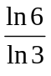 = ln 2 M0A0
ln x = ln 6 – ln 3 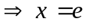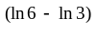 allow M1, x = 2 (no wrong working) A1

- 1st M1 for attempting to multiply through by e^{x} : Allow y, X , even x, for e
2nd M1 is for solving quadratic as far as getting two values for e^{x} or y or X etc
3rd M1 is for converting their answer(s) of the form e^{x} = k to x = lnk (must be exact)
A1 is for ln3 and ln1 or 0 (Both required and no further solutions)

2. (a) | 2x² + 3x – 2 = (2x – 1)(x + 2) at any stage | B1
 | f(x) = 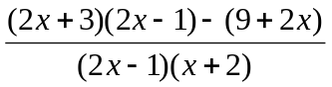 f.t. on error in denominator factors  (need not be single fraction) | M1, A1√
 | Simplifying numerator to quadratic form | M1
 | Correct numerator = 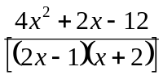 | A1
 | Factorising numerator, with a denominator = 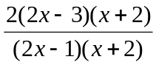 o.e. | M1
 | = 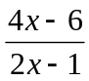 () | A1 cso (7)
Alt.(a) | 2x² + 3x – 2 = (2x – 1)(x + 2) at any stage B1
 | f(x) = 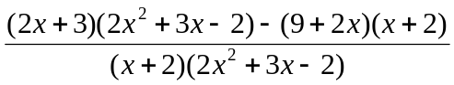 M1A1 f.t.
 | = 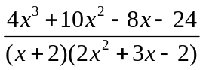
= 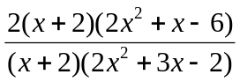 or 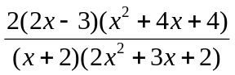 o.e.
Any one linear factor × quadratic factor in numerator M1, A1
 | = 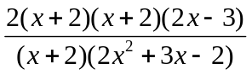 o.e. M1
 | = 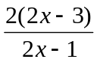 () A1
(b) | Complete method for 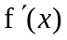; e.g 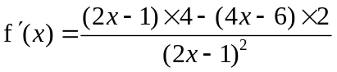 o.e | M1 A1
 | = 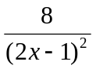 or 8(2x – 1)^{–2} | A1 (3)
 | Not treating 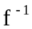 (for 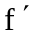) as misread | (10 marks)

Notes: (a) 1st M1 in either version is for correct method

1st A1 Allow 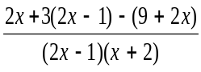 or 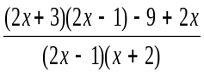 or 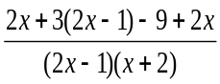 ( fractions)

2nd M1 in (main a) is for forming 3 term quadratic in numerator

3rd M1 is for factorising their quadratic (usual rules) ; factor of 2 need not be extracted

() A1 is given answer so is cso

Alt :(a) 3rd M1 is for factorising resulting quadratic

(b) SC: For M allow given expression or one error in product rule

Alt: Attempt at f(x) = 2 – 4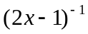 and diff. M1; 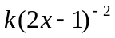 A1; A1 as above

Accept 8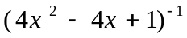.

Differentiating original function – mark as scheme.

Question Number | Scheme | Marks
3. (a) | 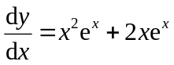 | M1,A1,A1 (3)
(b) | If 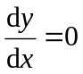, e^{x}(x² + 2x) = 0 setting (a) = 0 | M1
 | [e^{x} ≠ 0] x(x + 2) = 0
 | ( x = 0 ) x = –2 | A1
 | x = 0, y = 0 and x = –2, y = 4e^{–2} ( = 0.54…) | A1 √ (3)
(c) | 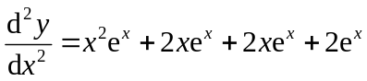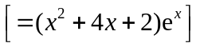 | M1, A1 (2)
(d) | x = 0, 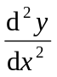> 0 (=2) x = –2, < 0 [ = –2e^{–2} ( = –0.270…)]  M1: Evaluate, or state sign of, candidate’s (c) for at least one of candidate’s x value(s) from (b) | M1
 | ∴minimum ∴maximum | A1 (cso) (2)
Alt.(d) | For M1:  Evaluate, or state sign of, 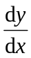at two appropriate values – on either side of at least one of their answers from (b) or  Evaluate y at two appropriate values – on either side of at least one of their answers from (b) or  Sketch curve
 |  | (10 marks)

Notes: (a) M for attempt at 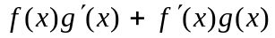

1st A1 for one correct, 2nd A1 for the other correct.

Note that 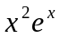 on its own scores no marks

1st A1 (x = 0) may be omitted, but for
2nd A1 both sets of coordinates needed ; f.t only on candidate’s x = –2

(c) M1 requires complete method for candidate’s (a), result may be unsimplified for A1

(d) A1 is cso; x = 0, min, and x = –2, max and no incorrect working seen,

or (in alternative) sign of 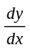 either side correct, or values of y appropriate to t.p.

Need only consider the quadratic, as may assume e ^{x} > 0.

If all marks gained in (a) and (c), and correct x values, give M1A1 for correct statements

with no working

Question Number | Scheme |  | Marks
4. (a) | x²(3 – x) – 1 = 0 o.e. (e.g. x²(–x + 3) = 1) |  | M1
 | 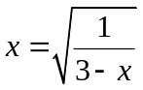 ()  Note(), answer is given: need to see appropriate working and A1 is cso  [Reverse process: Squaring and non-fractional equation M1, form f(x) A1] |  | A1 (cso) (2)
(b) | x₂ = 0.6455, x₃ = 0.6517, x₄ = 0.6526  1st B1 is for one correct, 2nd B1 for other two correct  If all three are to greater accuracy, award B0 B1 |  | B1; B1 (2)
(c) | Choose values in interval (0.6525, 0.6535) or tighter and evaluate both |  | M1
 | f(0.6525) = –0.0005 ( 372… f(0.6535) = 0.002 (101…  At least one correct “up to bracket”, i.e. -0.0005 or 0.002 |  | A1
Alt (i)  Alt (ii) | Change of sign, ∴ x = 0.653 is a root (correct) to 3 d.p.  Requires both correct “up to bracket” and conclusion as above  Continued iterations at least as far as x₆ M1  x₅ = 0.65268, x₆ = 0.6527, x₇ ₌ … two correct to at least 4 s.f. A1  Conclusion : Two values correct to 4 d.p., so 0.653 is root to 3 d.p. A1  If use g(0.6525) = 0.6527..>0.6525 and g(0.6535) = 0.6528..<0.6535 M1A1  Conclusion : Both results correct, so 0.653 is root to 3 d.p. A1 |  | A1 (3)  (7 marks)
5.  (a) | Finding g(4) = k and f(k) = …. or fg(x) = 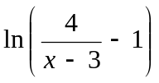 |  | M1
 | [ f(2) = ln(2x2 – 1) fg(4) = ln(4 – 1)] = |  | A1 (2)
(b) | 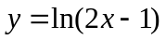 ⇒ 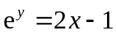 or 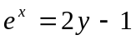 |  | M1, A1
 | f^{–1}(x) = 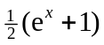 Allow y = |  | A1
 | Domain x ∈ 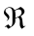 [Allow , all reals, (-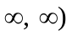] independent |  | B1 (4)
(c) | _{y}  _{x = 3}  O 3 x | Shape, and x-axis should appear to be asymptote | B1
(c) |  | Equation x = 3  needed, may see in diagram (ignore others) | B1 ind.
(c) |  | Intercept (0, ) no other; accept y = ⅔ (0.67) or on graph | B1 ind (3)
(d) | 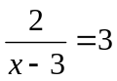 ⇒ x = 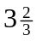 or exact equiv. |  | B1
 | 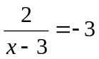 , ⇒ x = 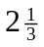 or exact equiv.  Note: 2 = 3(x + 3) or 2 = 3(–x – 3) o.e. is M0A0 |  | M1, A1 (3)
Alt: | Squaring to quadratic (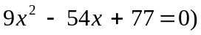 and solving M1; B1A1 |  | (12 marks)

6. (a) | Complete method for R: e.g. 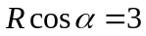, 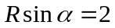, 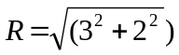 | M1
 | 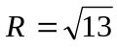 or 3.61 (or more accurate) | A1
 | Complete method for 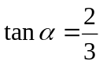 [Allow 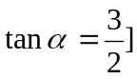  α = 0.588 (Allow 33.7°) | M1  A1 (4)
(b) | Greatest value = 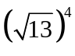= 169 | M1, A1 (2)
(c) | 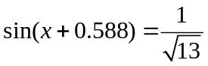 ( = 0.27735…) sin(x + their α) = 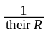 | M1
 | ( x + 0.588) = 0.281( 03… ) or 16.1° | A1
 | (x + 0.588) = π – 0.28103…  Must be π – their 0.281 or 180° – their 16.1° | M1
 | or (x + 0.588) = 2π + 0.28103…  Must be 2π + their 0.281 or 360° + their 16.1° | M1
 | x = 2.273 or x = 5.976 (awrt) Both (radians only) | A1 (5)
 | If 0.281 or 16.1° not seen, correct answers imply this A mark | (11 marks)

Notes: (a) 1st M1 for correct method for R
2nd M1 for correct method for tan
No working at all: M1A1 for √13, M1A1 for 0.588 or 33.7°.
N.B. Rcos α = 2, Rsin α = 3 used, can still score M1A1 for R, but loses the A mark for α.
cosα = 3, sin α = 2: apply the same marking.

(b) M1 for realising sin(x + ) = ±1, so finding R⁴.

(c) Working in mixed degrees/rads : first two marks available
Working consistently in degrees: Possible to score first 4 marks
[Degree answers, just for reference only, are 130.2° and 342.4°]
Third M1 can be gained for candidate’s 0.281 – candidate’s 0.588 + 2π or equiv. in degrees
One of the answers correct in radians or degrees implies the corresponding M mark.

Alt: (c) (i) Squaring to form quadratic in sin x or cos x M1
Correct values for cos x = 0.953… , –0.646; or sin x = 0.767, 2.27 awrt A1
For any one value of cos x or sinx, correct method for two values of x M1
x = 2.273 or x = 5.976 (awrt) Both seen anywhere A1
Checking other values (0.307, 4.011 or 0.869, 3.449) and discarding M1

(ii) Squaring and forming equation of form a cos2x + bsin2x = c
Setting up to solve using R formula e.g. √13 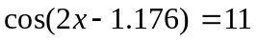 M1
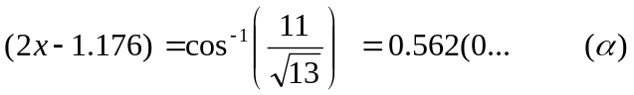 A1
M1
x = 2.273 or x = 5.976 (awrt) Both seen anywhere A1
Checking other values and discarding M1

Question Number | Scheme |  | Marks
7. (a) | 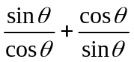= 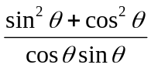  M1 Use of common denominator to obtain single fraction |  | M1
 | = 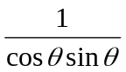  M1 Use of appropriate trig identity (in this case 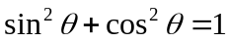) |  | M1
 | = 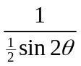 Use of 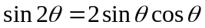 |  | M1
 | = 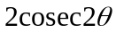 () |  | A1 cso (4)
Alt.(a) | 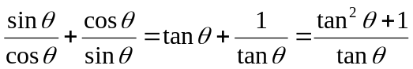 M1
 | = 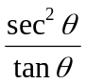 M1
 | = = M1
= () (cso) A1
If show two expressions are equal, need conclusion such as QED, tick, true.
(b) | _{y}  ₂  O 90° 180° 270° 360° θ  _{–2} | Shape  (May be translated but need to see 4“sections”) | B1
(b) | _{y}  ₂  O 90° 180° 270° 360° θ  _{–2} | T.P.s at y = ±2 , asymptotic at correct  x-values (dotted lines not required) | B1 dep. (2)
(c) | 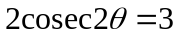
 | 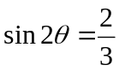 Allow 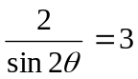 [M1 for equation in sin2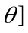 |  | M1, A1
 | (2θ ) = [ 41.810…°, 138.189…° ; 401.810…°, 498.189…°]  1st M1 for 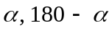 ; 2nd M1 adding 360° to at least one of values |  | M1; M1
Note | θ = 20.9°, 69.1°, 200.9°, 249.1° (1 d.p.) awrt  1st A1 for any two correct, 2nd A1 for other two  Extra solutions in range lose final A1 only  SC: Final 4 marks:θ = 20.9°, after M0M0 is B1; record as M0M0A1A0 |  | A1,A1 (6)
Alt.(c) | 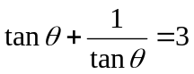 and form quadratic , 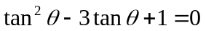 M1, A1  (M1 for attempt to multiply through by tanθ, A1 for correct equation above)
 | Solving quadratic [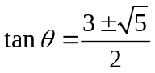 = 2.618… or = 0.3819…] M1
 | θ = 69.1°, 249.1° θ = 20.9°, 200.9° (1 d.p.) M1, A1, A1  (M1 is for one use of 180° + °, A1A1 as for main scheme) |  | (12 marks)

Question Number | Scheme | Marks
8. (a) | D = 10, t = 5, x = 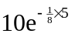 | M1
 | = 5.353 awrt | A1 (2)
(b) | D = 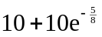, t = 1, x = 15.3526…×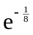 | M1
 | x = 13.549 () | A1 cso (2)
Alt.(b) | x = 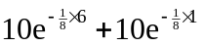 M1 x = 13.549 () A1 cso
(c) | 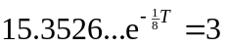 | M1
 | 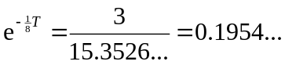
 | 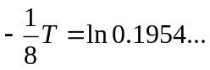 | M1
 | T = 13.06… or 13.1 or 13 | A1 (3)
 |  | (7 marks)

Notes: (b) (main scheme) M1 is for (), or {10 + their(a)}

N.B. The answer is given. There are many correct answers seen which deserve M0A0
or M1A0

(c) 1st M is for () 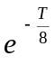 = 3 o.e.

2nd M is for converting = k (k > 0) to 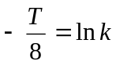. This is independent of 1st M.

Trial and improvement: M1 as scheme,
M1 correct process for their equation (two equal to 3 s.f.)
A1 as scheme

